



**Creo Direct Embedded Client Live Integration**

PLM-S

Damstraat 70 - B 9220 Hamme (VL), BE 0684.702.709

www.plm-s.com

**User Guide - V 5.4**

Table of Contents

Table of Contents 1

Teamcenter Menu 3

Teamcenter Tab 3

Buttons 3

Teamcenter Session 4

Teamcenter Session Login 4

Teamcenter Session Logout 5

Open from Teamcenter 5

Home Folder 6

Refresh 6

Search 6

Search Result 7

Save To Teamcenter 8

Save To Teamcenter Menu 9

Buttons 9

Backend Process Messages 11

Property Update 12

Revise 12

Copy Paste 12

Warning Message Section 12

Cache Assistant 13

Save To Cache 13

Open from cache 13

Clear Cache 13

Active Workspace 14

Neutral Files 14

Check-Out & Cancel Check-Out 15

Check-Out 15

Cancel Check-Out 15

User Settings 15

Workflow Process 17

Assign Project 16

New functionalities 18

Replace Component 18

Reopen component 18

Save As in Teamcenter 19

Open related drawing 19

Show item in Teamcenter 20

Refresh metadata from Teamcenter 20

Opening multiple components 21

Common issues 25

Warning: 28

Document History 30

Teamcenter Menu

**Teamcenter Tab**

**Buttons**



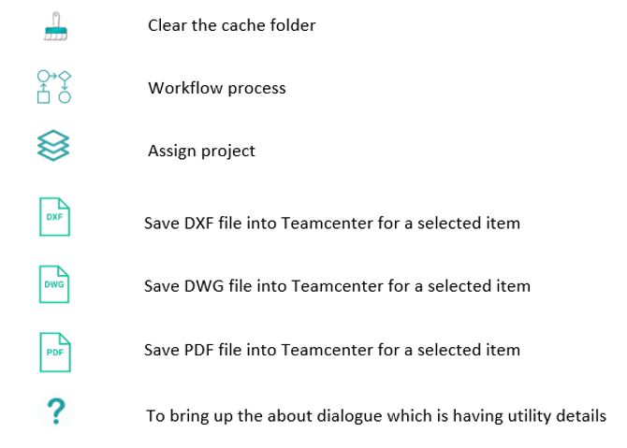

Teamcenter Session

**Teamcenter Session Login**

Go to the Teamcenter tab and click  to bring up the login to the Teamcenter window.

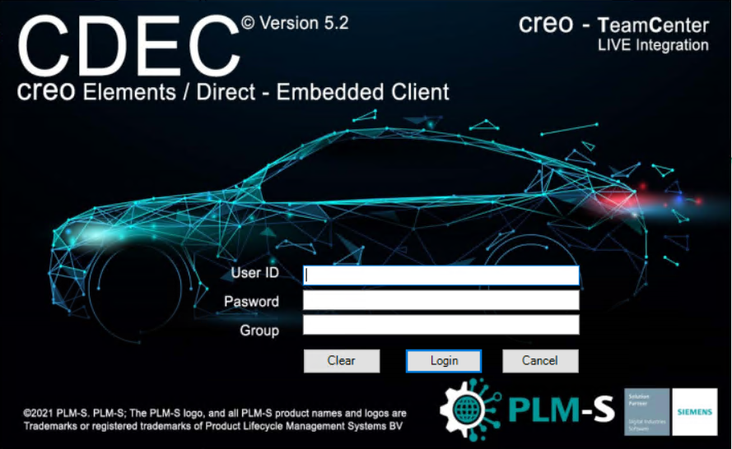

The live session is created and saved using the Teamcenter credentials. The user can log in at any point in time when he thinks to upload the data to Teamcenter and work in live integration mode.

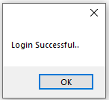

**Teamcenter Session Logout**

Click  to log out from the Teamcenter session. The user session is valid until the application will be closed or until the user clicks the logout.

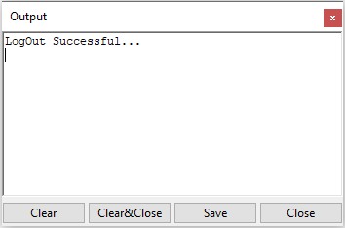

Open from Teamcenter

Click  to load a Creo file from the user home folder or use the search option. The queries visible in the search LOV are configurable through a Teamcenter preference. When the dialog opens, the user's home folder is automatically loaded.

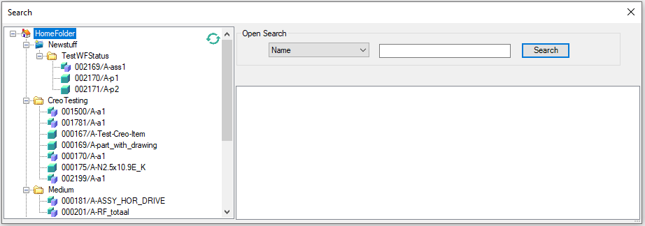

In the open dialog, the user can open an assembly or part from Teamcenter in multiple ways

**Home Folder**

The assembly or part which is attached under the home folder of the user in Teamcenter can be seen in the left section of the open dialog.

To open the assembly or part, double click on the item attached below the Home folder.

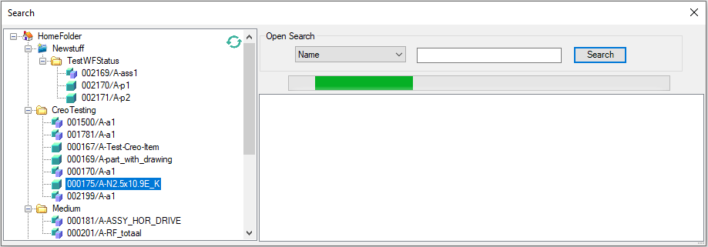

**Refresh**

An item attached under the home folder in Teamcenter will not be reflected immediately in Open Dialog, So the user has to click the refresh  button to update the home folder.

**Search**

The search dialog loads the query search criteria parameters based on the query selected. An assembly can be opened by using a list of search options in the open search.

Click the drop-down to select the required search format.

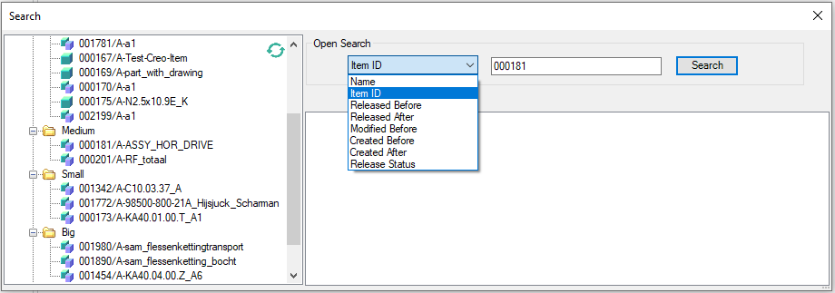

Enter the respective value and click Search

**Search Result**

To load the Creo model in Creo, right-click, then choose open in Creo or double-click on the item.

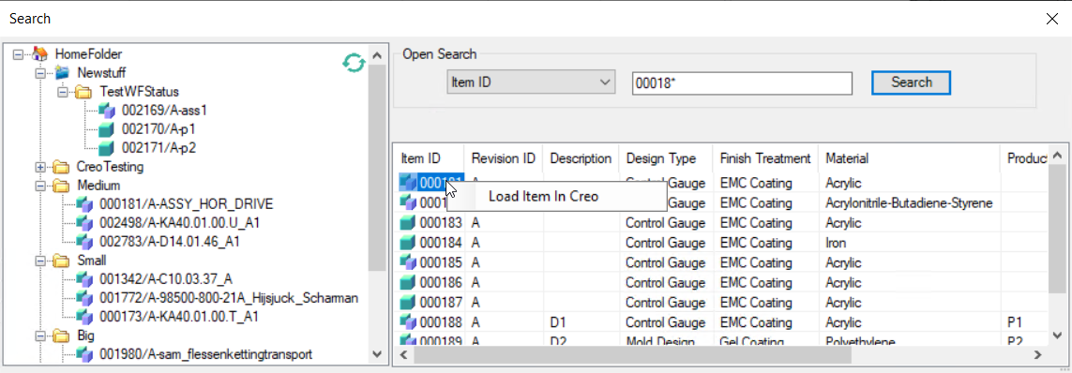

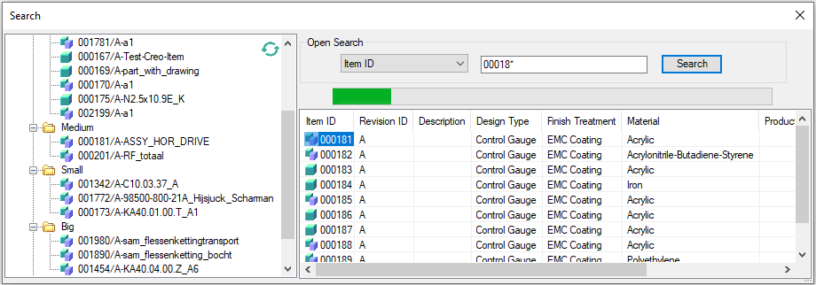

The columns show the different properties of the Item Revision. The columns are configurable through Teamcenter preferences.

Save To Teamcenter

After modifying the assembly or part select the top item and click Save  icon in the Teamcenter tab

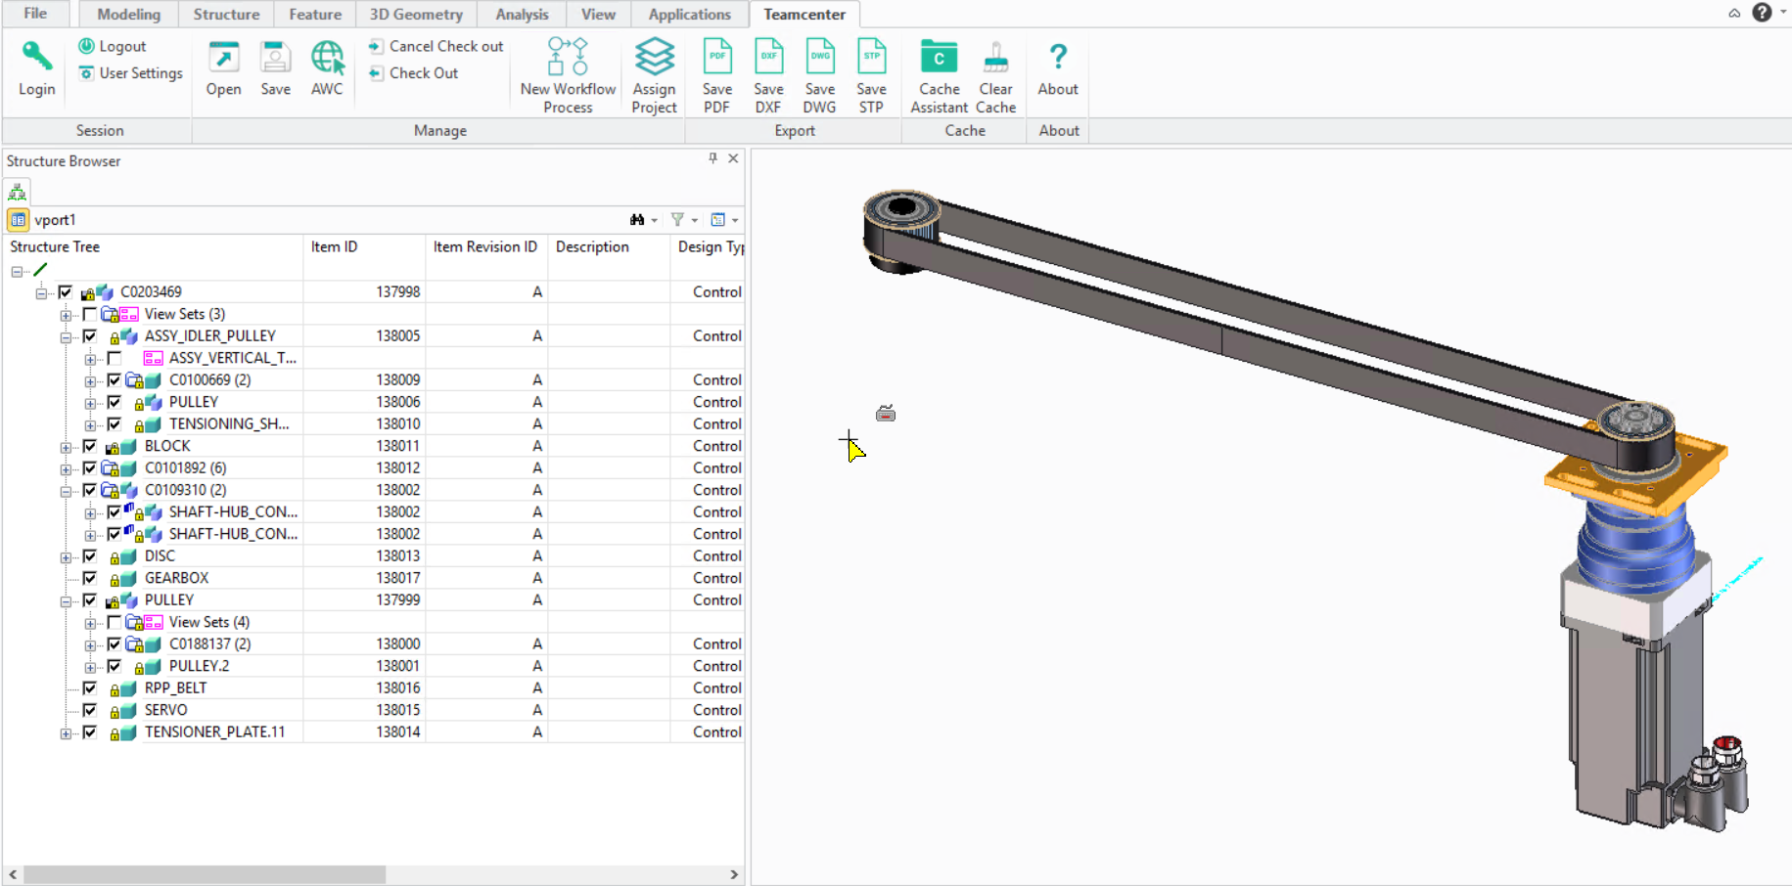

**Note:**

Here, the **Model Name** isn’t a must and can be different from the **Name**

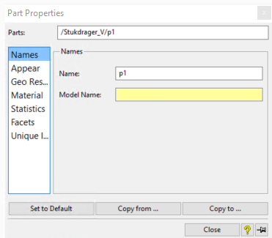

**Save To Teamcenter Menu**

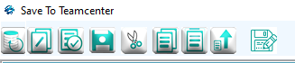

**Buttons**

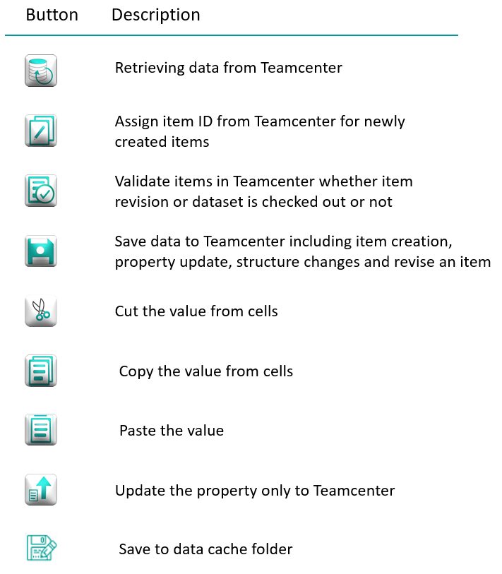

Click  to assign item ID from Teamcenter for newly created objects in Creo. Item ID will be reserved in Teamcenter for newly created objects in the assembly

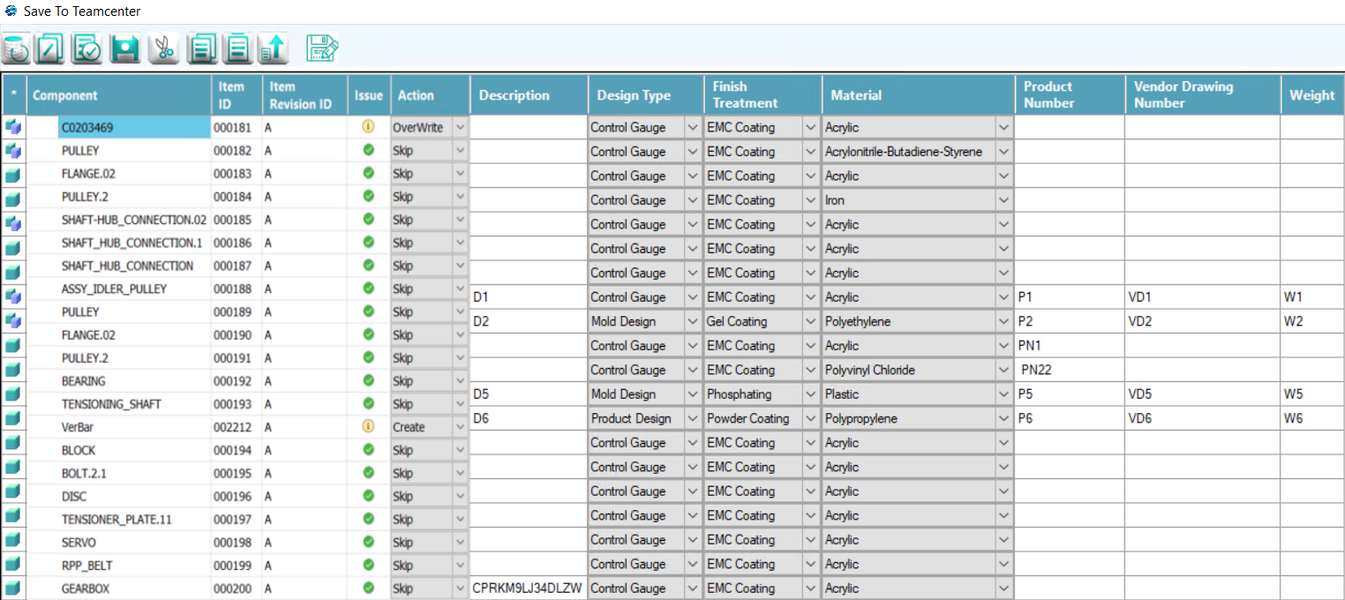

Click  to validate existing items in Teamcenter. This will return a warning message if the Item revision or Creo dataset is checked out. Warning or Error messages will be shown in the bottom right side section.

Click the save icon  to save the assembly to Teamcenter

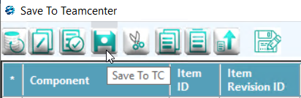

After the save action is completed, a dispatcher request will be created to create a .png file in the item automatically. To generate the .png image automatically during the Save operation, the value of **Cd4_Enable_CreoToPNG** preference in the Creo_Preference category must be 1

**Cd4_Enable_CreoToPNG**

**DESCRIPTION**

0 – Disabled, 1 – Enabled.

When the default value is 1 CreotoPNG workflow will be triggered on the item for which the Save operation is performed in CDEC

When the default value is 0 CreotoPNG workflow will not be triggered on the item for which the Save operation is performed in CDEC

**VALID**

**VALUES**

0

1

**DEFAULT**

**VALUE**

1

**DEFAULT**

**PROTECTION**

**SCOPE**

User preference.

creo to png - will generate the png of the item in a dispatcher

**Backend Process Messages**

Save to Teamcenter can be tracked by using the status bar and left bottom grid. The left bottom grid will show the backend process status.

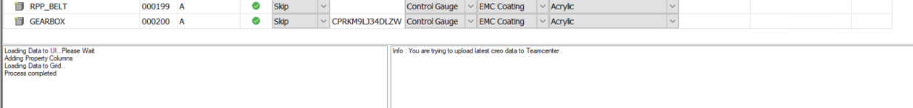

**Property Update**

We can update property alone by using the property update  button instead of updating the whole assembly. If we modified any cells in the grid, the corresponding action column will change automatically to **OverWrite** as shown in the below image.

**Revise**

We can revise an item by changing the **Action** column to revise.

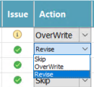

**Copy Paste**

We can copy and paste the values between the property cells by using the copy  and paste  button.

**Warning Message Section**

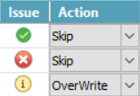

 Error – Cannot upload data to Teamcenter

 Info – Information to User, also a warning is displayed as info.

 Success – No issue to upload to Teamcenter

Click on the Error  or info  symbol to get full messages. These messages will show on the bottom right side **Warning message section.**

Cache Assistant

Cache assistant will help the user to save the current work into the cache folder instead of uploading it into Teamcenter. Users can continue the work by retrieving the saved data from the cache folder.

**Save To Cache**

Click Save to Cache  button to save current changes into the cache folder.

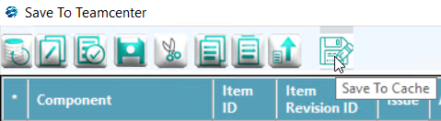

**Open from cache**

icon from the Teamcenter tab to bring up the cache assistant dialog, all the files stored in the cache will appear here.

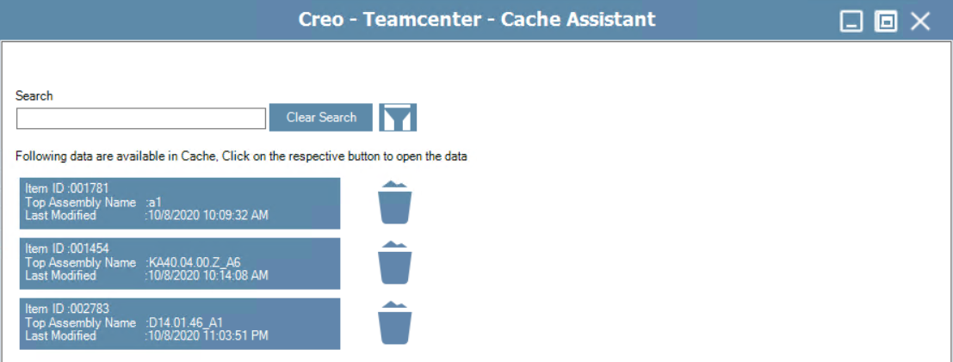

Double-click on the file name to open saved files from the cache folder.

Click  icon to delete the saved data from the cache folder.

Filter option  sorts the assemblies present in the cache.

**Clear Cache**

Click  to remove all files in the cache folder.

Active Workspace

Click the Active workspace  icon from the Teamcenter tab to launch an Active workspace.

We can open Creo assembly or part from Active workspace by using the **Open in Creo** option. This option is only enabled on Item Revision which has the Creo Package dataset.

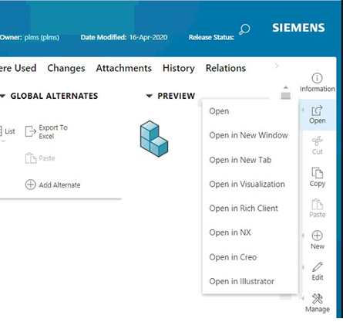

Neutral Files

The user has the choice to let the dispatcher generate the neutral files or use the options from the menu to generate the neutral files immediately on demand.

,

**and **CreotoPDF**.

All the neutral files will be attached next to the Creo dataset in the item revision. The relation between the item revision and the neutral files is configurable through a Teamcenter preference.

Check-Out & Cancel Check-Out

**Check-Out**

When opening a part/assembly, it will be opened with lock as default

Click  to perform remote check out the model(assembly/part/container) which is active and the parts which were modified in the Creo Session.

By default, the parts are not checked out in Teamcenter. The user decides when to check out the parts in Teamcenter and executes the action.

**Cancel Check-Out**

Click  to cancel check out the model(assembly/part/container) which is active in the Creo session.

The lock will be added to the model for which Cancel Check-Out is done

User Settings

Click the user settings  icon to bring up the Teamcenter settings dialogue.

Information like User, Group, Teamcenter URL, and Teamcenter FSC URL can be viewed here.

Also here we can set the Revision rule to download or upload assembly to Teamcenter.

The default revision rule would apply if the user did not select any revision rule.

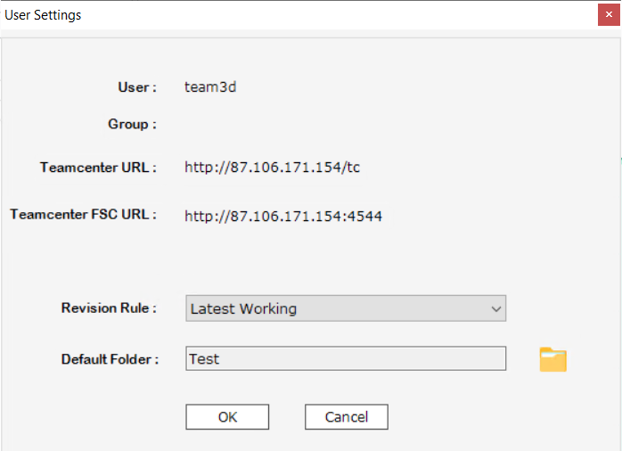

The default folder is used to attach the saved item to the respective home folder which is selected here

Assign Project

In the Foxconn case, a user has to Assign Project first for an item to trigger certain workflows. to assign/remove a project for the selected item.

Users can choose the Assign option in Action of the Assign Project window and move the project which has to be assigned from the left grid to the right grid using those arrows and click Apply

If a User has to remove a project, then the user can choose the Remove option in Action of the Assign Project window and move the project which has to be assigned from the left grid to the right grid using those arrows and click Apply

Workflow Process

Click  to create a new workflow process on the selected item

The workflow can be selected from the available list of workflows. The workflow process will be triggered on the selected item in Teamcenter.

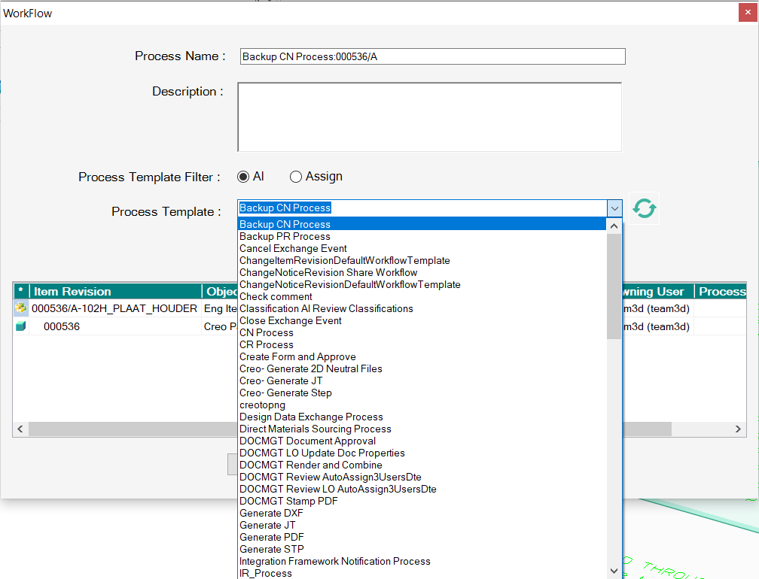

New functionalities

Replace Component

**Replace Component** function enables you to substitute one component in an assembly with a different component

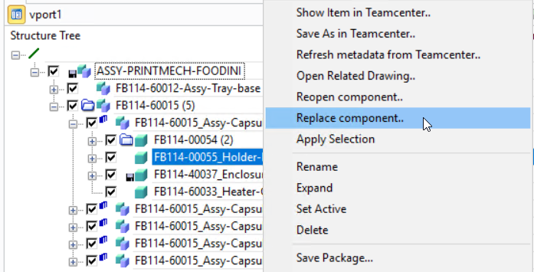

The open dialog appears after selecting the replace component option, contains a list of parts in the home folder. You can choose a part from the home folder or by using the search option

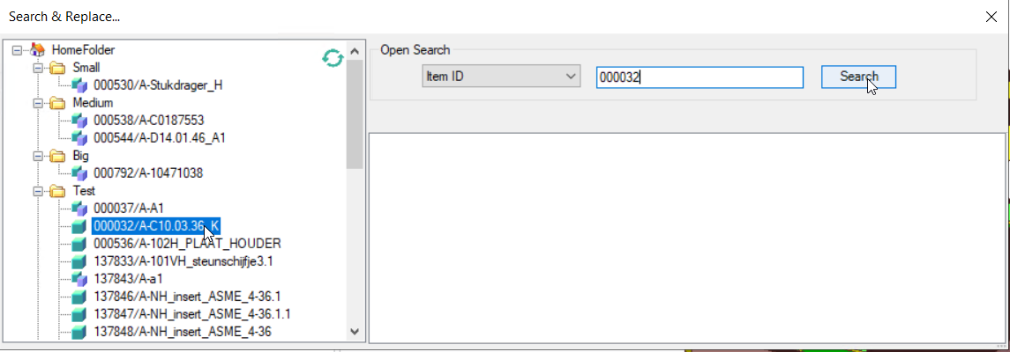

By default, the replacing component is not positioned so the user has to position the component.

Reopen component

Reopen component function enables you to reopen the same component in the Creo session

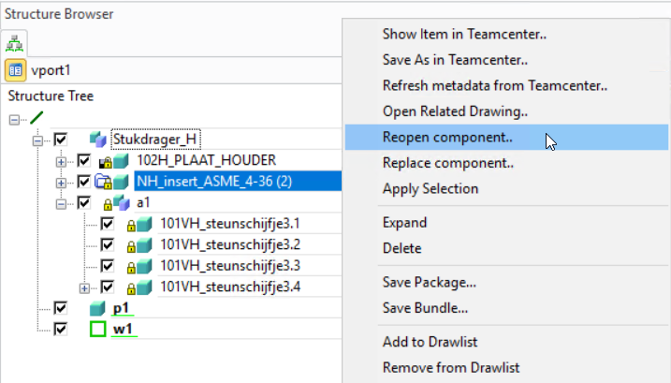

By default, the reopened component is not positioned so the user has to position the component.

Save As in Teamcenter

To copy a selected object and save it with a new name, we recommend that you select the component and use the **Right-Click**→**Save** **As in Teamcenter** command in Creo.However, if you do want to use the Teamcenter **Save As** command, you need to be aware of the following:

* New item ID & rev ID will be assigned and also the properties of the source item would be carried to the target item
* Some attributes of the new object, such as the ownership and the creation date, may be different from those of the original object.

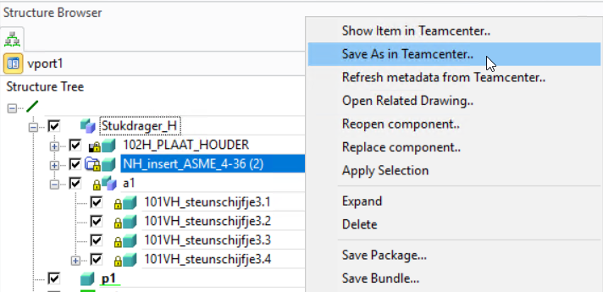

Open related drawing

You can easily open a related master or non-master drawing for a loaded, displayed part using the **Open Related Drawing** command. If the part has only one related drawing, that drawing is opened.

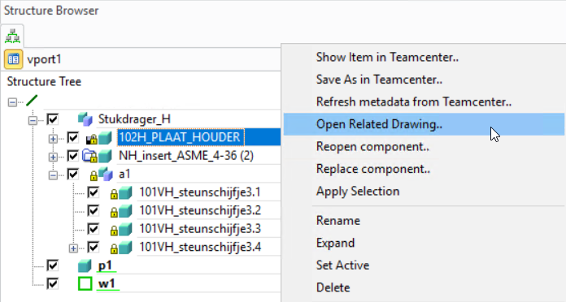

By opening this drawing, it will replace the already existing drawing in the annotation module

Show item in Teamcenter

The user needs to right-click on the component and select **Show item in Teamcenter** to open the item in Active Work Space.

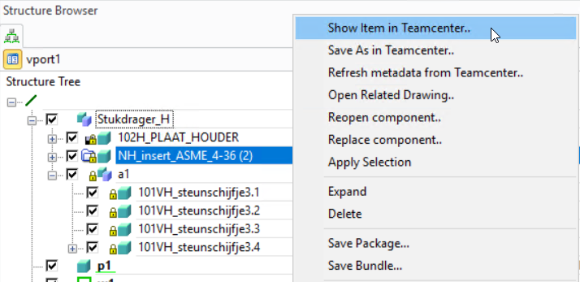

Refresh metadata from Teamcenter

Use the **Refresh metadata from the Teamcenter** command to update the Teamcenter view. This enables you to ensure the information displayed in the Teamcenter view is up to date with the information in Teamcenter.

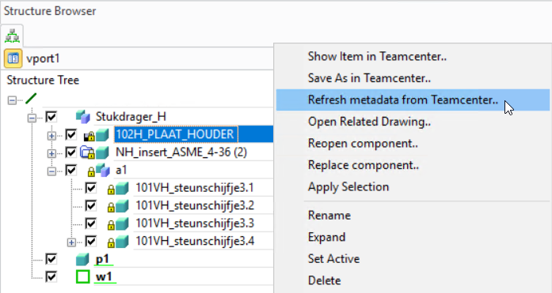

The **Refresh Teamcenter Information** command updates the loaded part information. The command detects whether the revision and version of a loaded part in NX are different from the revision or version in Teamcenter based on the revision rule currently set in the **User Settings** dialog box.

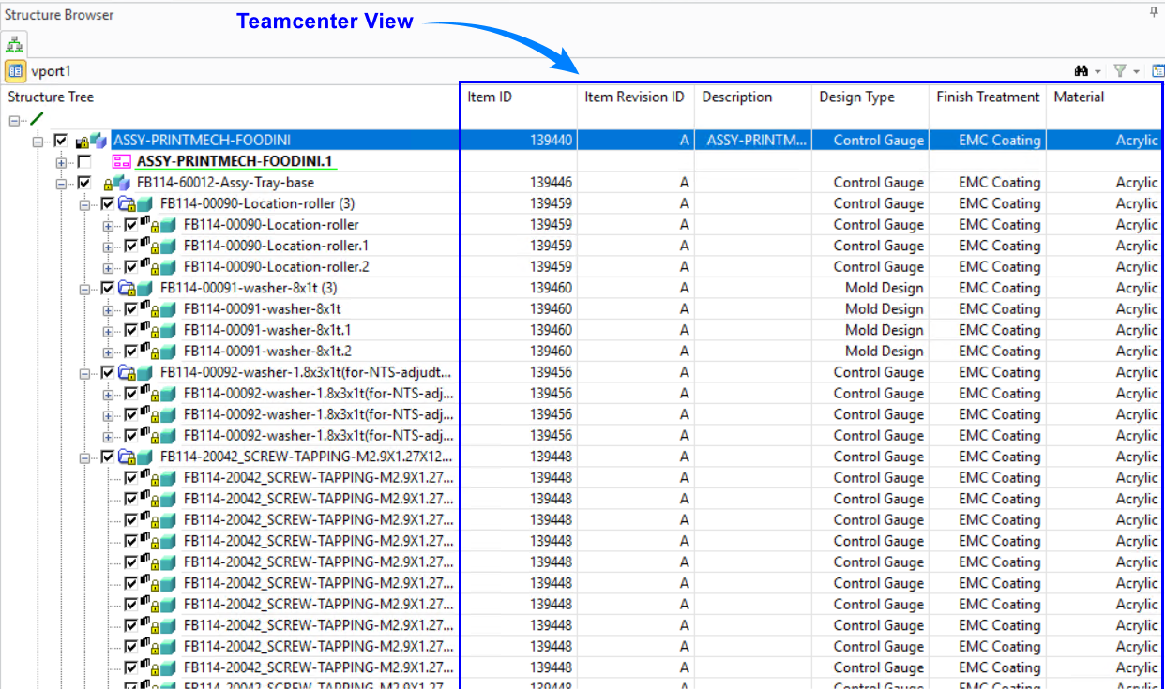

Opening multiple components

Using the open option, Multiple items can be opened from Teamcenter by already retaining the already opened components

Example:

1. Using the open option first the user can open any item in Creo from Teamcenter

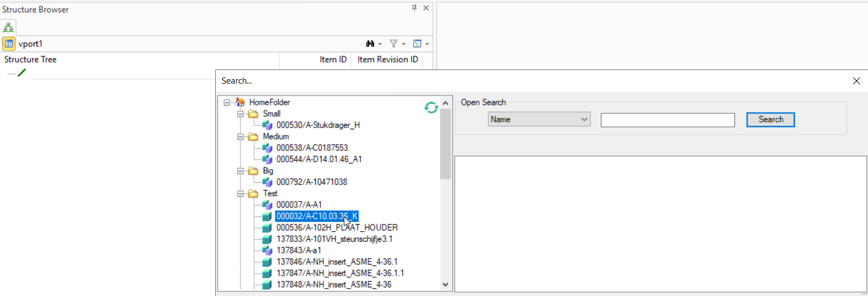

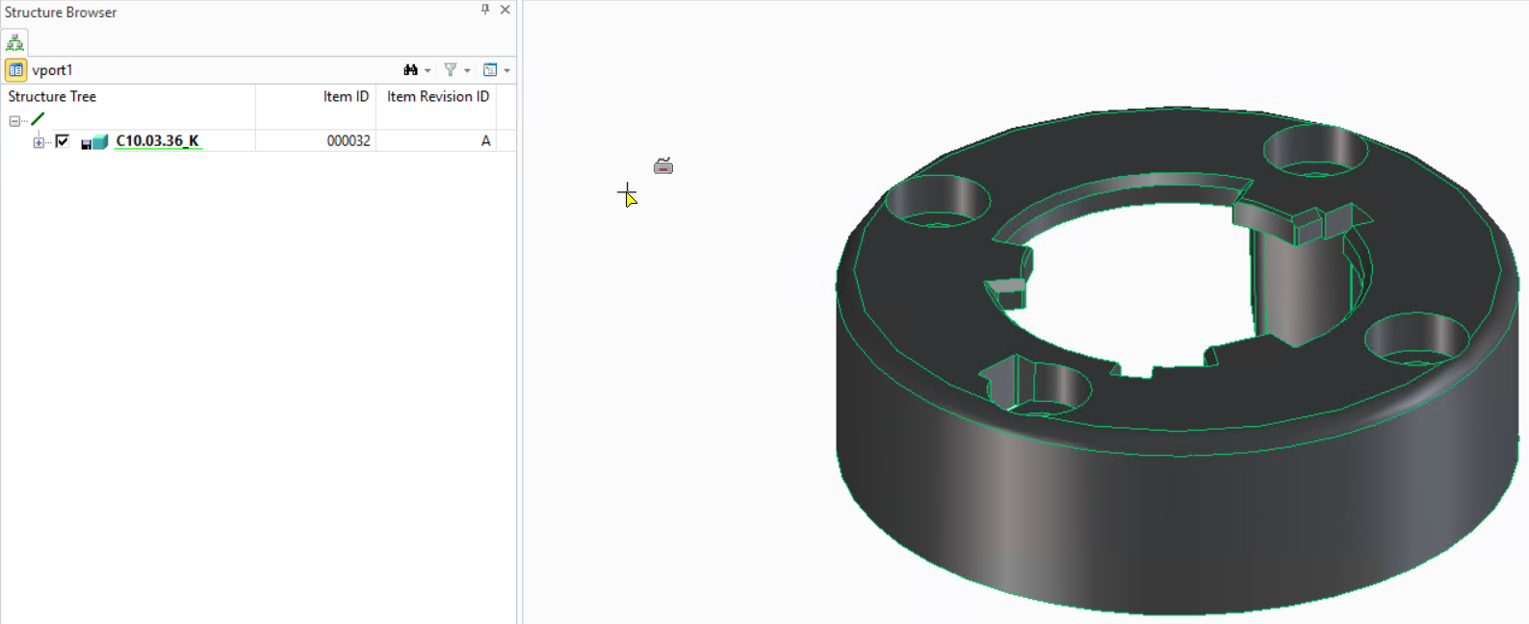

1. Then the user can open a different item from Teamcenter in the same session using the open option.

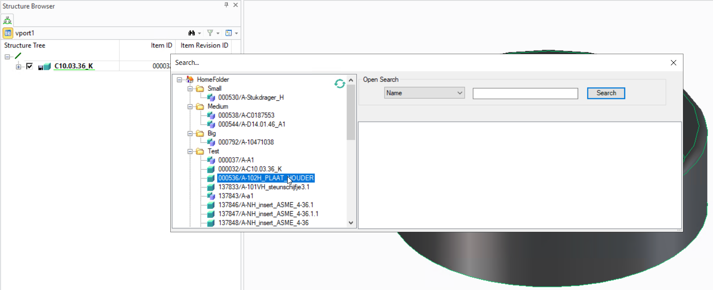

1. Opening the latest item from Teamcenter does not remove the already present model in Creo, it loads the latest model with the already present model in Creo

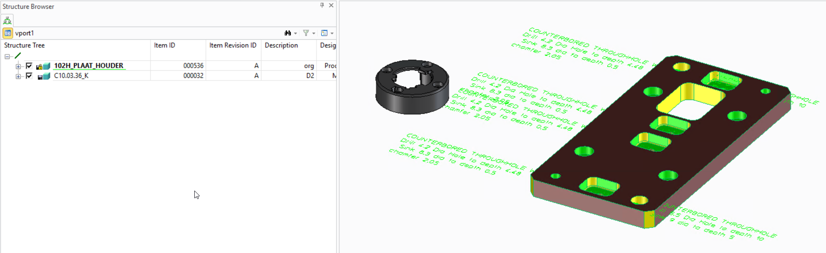

Revise Item Using Creo

Use **Revise Item in Teamcenter** to revise Item revision when

**Prerequisites Before Performing Revise Action**:-

1. Existing item revision should be released then only Teamcenter will allow you to revise item revision.

1. You should perform an action called Refresh metadata from Teamcenter on the Item revision you want to revise

Finally, you can perform Revise Item in Teamcenter action to get the desired result.

Changing Item Type in Save To Teamcenter

Users can change the item type while saving a new part and assembly using the drop-down in the “Item Type” column in the **Save** window

Item Naming Pattern in Save To Teamcenter

Users can assign **Item Naming Pattern** while saving items to Teamcenter by selecting the respective pattern before assigning the item id.

Revision Naming Rule in Save To Teamcenter

Users can assign **Revision Naming Pattern** while saving items to Teamcenter by selecting the respective pattern before assigning revision id.

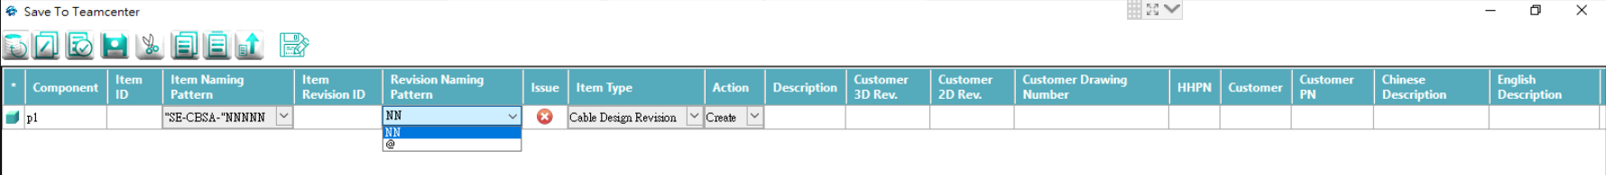

Common issues

1. If a user receives a “No CDEC License” error during the login of CDEC - Check whether **cdec_lic.exe is** running in the details tab of the task manager then terminate the **cdec_lic.exe** to release the locked CDEC license. **(*Refer to the image attached under point number 3 in this section*)**
2. If a user receives a “Maximum users exceeded” error then **Perform Status Enquiry** in **lmtools** and check whether the numbers of licenses provided are completely in use – check whether the number of licenses in use is equal to the number of users using the CDEC currently

1. This can be fixed by restarting the CDEC License Server.
   1. The procedure to do this activity is to go to **Start/Stop/Reread** tab in the lmtools and click on the **Stop Server** button. The status will go from “*Stopping Server Requested*” message to “*Stopping Server*”.

* 1. After this click on **Start Server** to start the CDEC License server and the status will show “*Start Server Successful*”

* 1. Then again **Perform Status Enquiry** in the **Server Status** tab to check whether the CDEC License is available

1. If the CDEC is crashed unexpectedly then go to the Details tab in the task manager and terminate the **cdec_lic.exe** to release the locked CDEC license.

1. Some times while creating an 3D model after login of CDEC can disrupt the Creo UI as shown in the below image so to solve this user has to restart the Annotation Module

Once the Annotation module is restarted then this UI will be reset to its original

**Warning:**

Do not terminate the cdec_lic.exe while working in the CDEC, this could affect the user to perform Teamcenter functionalities from Creo.

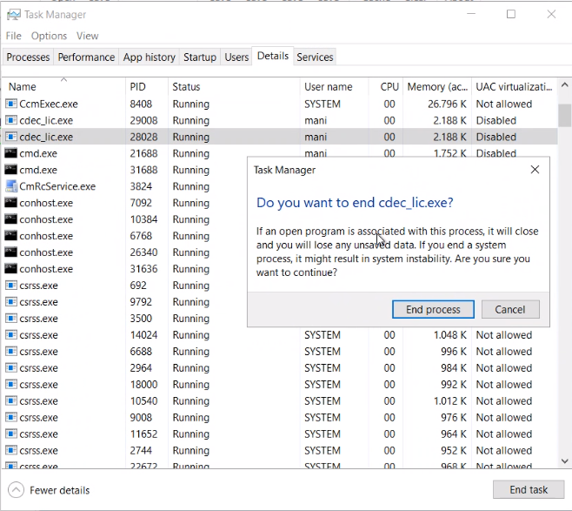

Document History

|  |  |  |  |
| --- | --- | --- | --- |
| Revision | Date | Author | Description |
| 2.0 | 15 Dec 2018 | Veera | Initial & Commercial Version Report |
| 3.0 | 22 May 2020 | Arun | Cache Manager, AWC & Enhancements |
| 5.3 | 29 Sep 2020 | Rajesh | User settings and Overall report enhancement |
| 5.4 | 21 March 2022 | Arun | New right-click revise Multiple item types, Item ID, and Rev ID Naming rule |